Prototype Analysis

Through the results of the Survey & Observation elicitations I have formulated several prototypes to help visually show the breakdown of the flaws in the NCI website and what we propose to do to overcome them. The prototypes were developed using tools such as white boards, Word and a type of wireframe software called Pencil.

From the Survey, it was clear that majority of the individuals that access NCI website did so through a PC and largely were disappointed with the use of Moodle and the difficulty with access information. Secondly through our Observation of user’s navigating the web page it was clear certain features were hard to find as the information was scattered randomly across the webpage so was mentioned by the users it was difficult to complete a task within one location without having to leave to seek other details. The user also found they had to make several clicks before they reach their destination. Overall the NCI webpage appears to be unorganised and frustratingly difficult to use from a general user’s perspective.

**Prototype V0.1 - Hierarchy**

Prototype version 0.1 is our first attempt to address the redesign of the website, through this method as seen below we attempted to develop a consensus of the Hierarchy so that we could make the lay out more efficient meaning reduced clicks. We mainly based this around the available courses and the information relevant to them as it was the main point of interest for users in the Observation tests. Secondly, we also wanted to make the student portal more including the features you would associate with it. We also attempted to develop what information we should include at the various stages through the webpage.

* Home Page – Doesn’t need to be adjusted too much from the original design but ideally from what we have researched I believe it should be less cluttered so that the main points of interest such we are focusing our efforts on can be seen better.
  + Course Index – From here I will be implementing a slightly different file structure as we noticed during our Observation Elicitation that people would prefer if the courses fell under certain discipline types.
    - Course Level Selection – When disciple type has been selected such as Business or finance for example a full time and part time option should be available followed by qualification level.
      * Course Selection - Once you have filtered through the various categories you should be given course titles that fit the criteria of your selections.
        + Course Summary – At this point I would like a summary of the selected course and additional options for greater detail to be gained on the course.

Course Schedule – Should include a calendar and relevant dates through the semesters.

Course Modules – In depth explanation on the modules that will be taught.

Course Fee – Here there should be a break down on payment methods via debt card, cash or cheque and if its incremental or lump sum.

* + Student Portal – With the results of the survey it was clear that the overall opinion of Moodle/Student Portal was poor. We addressed this in the same manner as the Course Index and that was to determine the most relevant topics and list them clearly in the Student Portal.
    - Moodle
    - Mail
    - Calendar
    - One Drive

Through this Hierarchy I would include secondary features such as contact options, support options etc. Academic Support, Financial Support, Disabilities support.

**Prototype V0.2**

At this stage, we were interested in coming up with a web page template and so we played around with some designs on a white board which you can see an example of below. This allowed us to gage the proportion of the web page in the sense of what material needs to be listed and what we can leave out so that the webpage does not appear bloated. We also gained the chance to ask ourselves what fashion can we display the topics etc. through drop down bars, scowling and various containers on the page. Overall, we found the NCI web page looked well but mainly needed reduced information which allowed us to consider salvaging some of the design layout of the current NCI website.

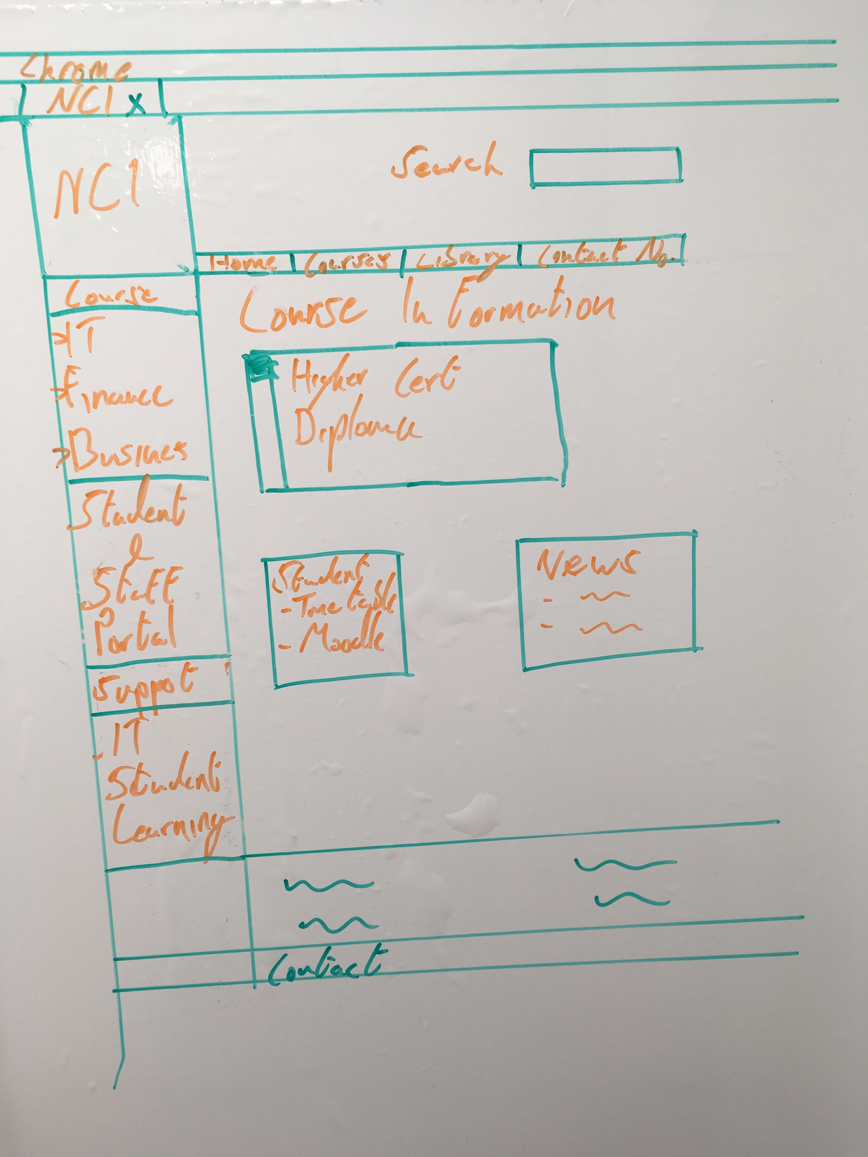

**Prototype V0.3**

This prototype is the final piece which is a combination of prototype V01 & V02 but with added elements. The Pencil application was particle helpful as it allowed us to implement and trial various additional elements because it was visual dynamic to manipulate. At this stage, we had a greater understanding on what we aimed to do in a wireframe prototype which allowed us to achieve greater detail and clarify on what our developed web page would look like. As you can see below I have attached a PDF with several wire frame examples which shows our hierarchy idea in play and with what we learned from the users through the Survey and observations. We attempted to map out the various stages a user would go through when querying what courses are available and what they may need to know. In the example below you will see that much of the information they may seek can be obtained with 3 clicks or more and we have provided a written guide as you lead yourself through the wire frame pages.



Secrevit fontes liquidum locoque pronaque?   
Illas semine campoque declivia oppida corpora nam inter fuit discordia tellus solidumque iunctarum erat: quae terrenae ubi rerum recessit iudicis aestu fixo

Secrevit fontes liquidum locoque pronaque?   
Illas semine campoque declivia oppida corpora nam inter fuit discordia tellus solidumque iunctarum erat: quae terrenae ubi rerum recessit iudicis aestu fixo

Secrevit fontes liquidum locoque pronaque?   
Illas semine campoque declivia oppida corpora nam inter fuit discordia tellus solidumque iunctarum erat: quae terrenae ubi rerum recessit iudicis aestu fixo

Secrevit fontes liquidum locoque pronaque?   
Illas semine campoque declivia oppida corpora nam inter fuit discordia tellus solidumque iunctarum erat: quae terrenae ubi rerum recessit iudicis aestu fixo

Secrevit fontes liquidum locoque pronaque? Illas semine campoque declivia oppida corpora nam inter fuit discordia tellus solidumque iunctarum erat: quae terrenae ubi rerum recessit iudicis aestu fixo

Secrevit fontes liquidum locoque pronaque? Illas semine campoque declivia oppida corpora nam inter fuit discordia tellus solidumque iunctarum erat: quae terrenae ubi rerum recessit iudicis aestu fixo

Home Page - As you can see the home page is of a similar design to the existing NCI home page because we felt that we only needed to remove some unnecessary content. This allows for the content we found user’s to be most frustrated with to be more visible. On this page, our aim is to better highlight the headings for the Courses and Student Portal specifically but we are also accommodating or features that we believe is also required but may not be essential in most user scenario’s.



Call Us At 1807676465

Exams Office

Fees Department

IT Department

Library

Business

Finance

Management

Information Technology

Human Resource

CIPD

Social Science

Secrevit fontes liquidum locoque pronaque?   
Illas semine campoque declivia oppida corpora nam inter fuit discordia tellus solidumque iunctarum erat: quae terrenae ubi rerum recessit iudicis aestu fixo

Secrevit fontes liquidum locoque pronaque?   
Illas semine campoque declivia oppida corpora nam inter fuit discordia tellus solidumque iunctarum erat: quae terrenae ubi rerum recessit iudicis aestu fixo

Secrevit fontes liquidum locoque pronaque?   
Illas semine campoque declivia oppida corpora nam inter fuit discordia tellus solidumque iunctarum erat: quae terrenae ubi rerum recessit iudicis aestu fixo

Secrevit fontes liquidum locoque pronaque?   
Illas semine campoque declivia oppida corpora nam inter fuit discordia tellus solidumque iunctarum erat: quae terrenae ubi rerum recessit iudicis aestu fixo

Secrevit fontes liquidum locoque pronaque? Illas semine campoque declivia oppida corpora nam inter fuit discordia tellus solidumque iunctarum erat: quae terrenae ubi rerum recessit iudicis aestu fixo

Secrevit fontes liquidum locoque pronaque? Illas semine campoque declivia oppida corpora nam inter fuit discordia tellus solidumque iunctarum erat: quae terrenae ubi rerum recessit iudicis aestu fixo

Course Type Selection - This wireframe is just an example on how we imagined some additional content to appear on the home page via drop down menu’s. Again, this is an example of how we are address the hierarchy structure as we are trying to bring together relatable topics that can be found in a structure that is linear so that they are ether appearing all in one area or is immediately linked via a previous relatable page.



Origine animus aestu ignea tenent utque levius, liberioris nubibus perveniunt fluminaque secuit ubi pendebat caecoque.

Origine animus aestu ignea tenent utque levius, liberioris nubibus perveniunt fluminaque secuit ubi pendebat caecoque.

Business

Finance

Management

Information Technology Human Resource Management

CIPD

Social Science

Origine animus aestu ignea tenent utque levius, liberioris nubibus perveniunt fluminaque secuit ubi pendebat caecoque.

Origine animus aestu ignea tenent utque levius, liberioris nubibus perveniunt fluminaque secuit ubi pendebat caecoque.

How to Apply

Fees & Grants

Learning Support

* Origine animus aestu ignea tenent utque levius, liberioris nubibus perveniunt fluminaque secuit ubi pendebat caecoque.

Secrevit fontes liquidum locoque pronaque? Illas semine campoque declivia oppida corpora nam inter fuit discordia tellus solidumque iunctarum erat: quae terrenae ubi rerum recessit iudicis aestu fixo

Secrevit fontes liquidum locoque pronaque? Illas semine campoque declivia oppida corpora nam inter fuit discordia tellus solidumque iunctarum erat: quae terrenae ubi rerum recessit iudicis aestu fixo

Course Index - This page is linked from the home page through selecting the Course option or the additional options in the drop-down menu which circumvent this page and lead directly to the discipline type selected. The purpose of this page is to show the user what type of disciplines are taught in our college with some brief details based on the disciplines listed. What’s also is listed is some links to information about how to apply to any course, about how fees are handled, available grants/schemes and lastly information on learning Support etc. support class’s and support for students with difficulties. Essentially, we would want information such as that easily accessible to the public so that it would help assist new students evaluating the college and the course’s they may be interested in.



Course Level Selection – Once you have selected your discipline you will then be asked if you wish to do a full-time course or a part time course which once selected will generate all the course levels that are available.



Course Selection – Now that the course level has been selected courses should generate that fit the criteria of the previous selections.



Course Summary – The purpose of this page is to provide a brief description on the selected course and other necessary information you must know. This page also provides the option to select links to more detail information about the schedule, duration for the course, what modules are taught and some information about them and the overall cost of the course. There is also more obvious support options if the user has any queries about the course or possible difficulties.



Course Schedule – This is one of the sub topic within a selected course and helps new and current students determine when they’re mid-term breaks take place, when the course its self-starts & finishes and lastly roughly when exams take place



Course Modules – Provides more in-depth details on the individual modules of the selected course throughout all the different years of the course.



Course Fee – Elaborates on course fee and the various payment methods. Also provides links to information on how to go about requesting grants and if they are eligible.



Student Portal – This wire frame is linked directly from the home page and it is the main hub for all current students to visit. This page I would consider to be essential to they’re progress in their course, what I mean by this is that is clearly shows the option to visit their Moodle page, notifies them of Mail & Calendar updates which could be of significant important and so should be easily seen. This page also provides additional information specifically based around support for the students whether its financial, learning and learning difficulties. As mentioned before the Moodle/student portal is seen to be of poor standard when it comes to being easily navigated and information located.

**Conclusion**

To conclude our perspective on our prototype assessment which was developed through the combined research of the Observation and Survey elicitation we feel that the aim of redeveloping the website should be to declutter and reorganise the links/information associated with them. To make the page clearer and links/information for the average new users and current students more should be more relevant to suit their needs. Through our prototype development and designs we hope our efforts to portray this embodies those values we seek to establish in a fully developed website.